Lumen Source - Engineering Guidelines
Version 0.7

1. Purpose
This document defines the engineering principles used to develop Lumen Source.
The goal is to maintain a scalable, reliable, and extensible codebase suitable for long-term development.

2. Core Architecture Rules

Rule 0: Desktop shell is Tauri
Lumen Source’s operator application is a Tauri desktop app (Tauri 2).
Naming convention: use “Lumen Source” in user-facing prose and UI. Use “lumen-source” where a single token is required (code, packages, repositories, services, URLs, and CLI examples); derived technical names use it as a prefix, e.g. “lumen-source-agent” and “lumen-source-core”.
Responsibilities:
- Native desktop window and OS integration (not a site opened in the user’s browser)
- Host the web UI (React + TypeScript) inside an OS webview
- Expose IPC/commands so the UI can call Rust core operations
- Package installable artifacts for Linux, Windows, and macOS
Architecture split:
- UI (React in Tauri webview): display, interaction, state visualization only
- Core (Rust in Tauri backend): catalog, hardware, recommendation, install, runtime, host/agent orchestration
- Inference runtimes (e.g. Ollama): external processes managed via the Runtime abstraction — not embedded in the webview
- Lumen Source Agent (future / remote targets): separate service on managed machines; the Tauri app is the operator console that talks to agents
Rationale: Tauri matches the React + Rust split, keeps the footprint lighter than bundling a full Chromium (Electron), and provides a clear security/IPC boundary for an app that downloads and starts runtimes.
Constraint: “Web UI” here means UI technology inside a desktop webview. Users launch Lumen Source as a normal desktop application.

Rule 1: Frontend does not contain business logic
The React UI (hosted in the Tauri webview) is responsible only for:
- Display
- User interaction
- State visualization
Business decisions belong in Rust.
Bad:
Frontend decides recommended model.
Good:
Frontend requests: “Give me recommendations.”
Backend decides.

Rule 2: Runtime abstraction is mandatory
No component may directly depend on Ollama.
All inference engines implement a common interface.
Example:
Runtime
|
+-- OllamaRuntime
|
+-- LlamaCppRuntime
|
+-- MLXRuntime
This ensures future compatibility.

Rule 3: Local inference, networked setup
Default behavior:
- Inference and user data stay on the target device
- No cloud inference dependency
- No mandatory user accounts for the free product
Network access is expected for catalog updates and component downloads. Operator↔agent management traffic is expected for remote machines. Cloud/team features must remain optional.

Rule 4: Modules communicate through interfaces
Avoid direct dependencies.
Bad: RecommendationEngine → Ollama
Good: RecommendationEngine → Runtime Interface → Ollama

Rule 5: Lumen Source owns the catalog
Compatibility, recommendations, download URLs, and integrity metadata come from Lumen Source’s catalog — not from a runtime’s opportunistic listing alone.
Requirements:
- Fetch catalog updates on startup / on a defined refresh policy
- Validate catalog authenticity (signature or equivalent trust chain)
- Cache the last-known-good catalog locally for degraded operation
- Pin catalog schema versions for forward/backward compatibility
- Keep install recipes per runtime behind the Runtime interface
- Agents must apply the same catalog trust checks when installing on remote hosts
Delivery preference for v1: a signed, versioned catalog artifact served over HTTPS (static CDN or a thin API). Prefer the simplest reliable delivery that supports signing, caching, and rollback. Do not invent a large backend until team features require one.

Rule 6: No first-party AI chat surface
Lumen Source installs, verifies, configures, and runs local inference. It must not ship a built-in chat/assistant UI. Success is a healthy runtime endpoint and clear connection details for external tools.

Rule 7: Operator console + Lumen Source Agent
Lumen Source’s main application is the operator console. Remote machines (and optionally a unified local path) are managed through the Lumen Source Agent — a small service on the target host that exposes a constrained management API.

Architecture
Lumen Source (operator)
| authenticated management channel
v
Lumen Source Agent (system service on target)
|
+-- hardware facts + usage sampling
+-- catalog-driven install/verify
+-- Runtime interface (start/stop/status)
The operator UI may run on one machine while install/runtime actions execute on another via the agent.

Agent API (minimum surface)
The agent API shall support operations equivalent to:
- hardware.facts — capacity inventory (CPU/GPU/VRAM/RAM/storage/accelerators/OS)
- hardware.usage — current/recent utilization and model/runtime resource footprint
- runtime.install / runtime.update / model.install / model.remove — catalog-driven, verified
- model.start / model.stop
- status — installed components, versions, health, inference endpoint
- agent.enroll / agent.heartbeat — enrollment and liveness
The agent must not provide arbitrary remote shell/command execution. Only typed management operations are permitted.

Enrollment from the main application
- Lumen Source generates a short-lived or single-use enrollment token and agent install instructions/artifacts
- Bootstrap of the agent binary/package is out-of-band (console, packages, cloud-init/golden image; SSH optional)
- After enrollment, day-2 operations use the agent API only — SSH is not required
- Rotate/revoke agent credentials from the operator console

Hardware facts vs usage
Agents (and the local host adapter) must separate:
- Facts/capacity — relatively static inventory used for compatibility filtering
- Usage — sampled metrics over time used for under/over-utilization and right-sizing recommendations
Recommendation logic consumes both. Implementation should keep sampling lightweight and avoid continuous heavy instrumentation.

Engineering requirements
- Remote management goes through a Host/Agent abstraction (not ad-hoc SSH strings in UI code)
- The same Runtime, catalog, recommendation, and install orchestration logic must be reusable for local and agent targets
- Prefer a least-privilege agent over open-ended remote shell
- Authenticate the management channel (enrollment token → long-term agent credentials; prefer mTLS or equivalent)
- All remote operations must be auditable (structured logs: target host, action, artifact, result)
- Network failures, partial installs, and target reboots must yield explicit recoverable error states
- Do not require a cloud control plane for LAN/VPN-reachable agents in the initial design
- Keep the local single-machine path simple and independent of multi-agent features
- Share hardware detection/usage code between local mode and agent builds where practical (same crate/features)

Deployment topology diagrams
These diagrams show the component boundaries and control flow for the two deployment modes. In both cases, the UI requests operations; Rust owns decisions and orchestration; runtime access stays behind abstractions.
Local deployment
Lumen Source runs on the target machine. LocalHost connects the shared orchestration layer to local hardware detection, installation, and runtime control.
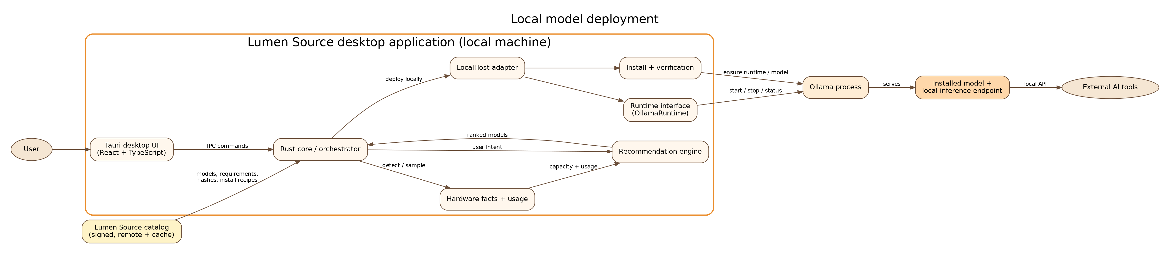
The resulting inference endpoint belongs to the runtime and is consumed by external tools; Lumen Source does not provide a chat interface.
Remote deployment
Lumen Source runs on the operator workstation. AgentHost sends typed, authenticated management operations to the Lumen Source Agent on the remote server or VM. The agent performs hardware monitoring, verified installation, and runtime control locally on that target.
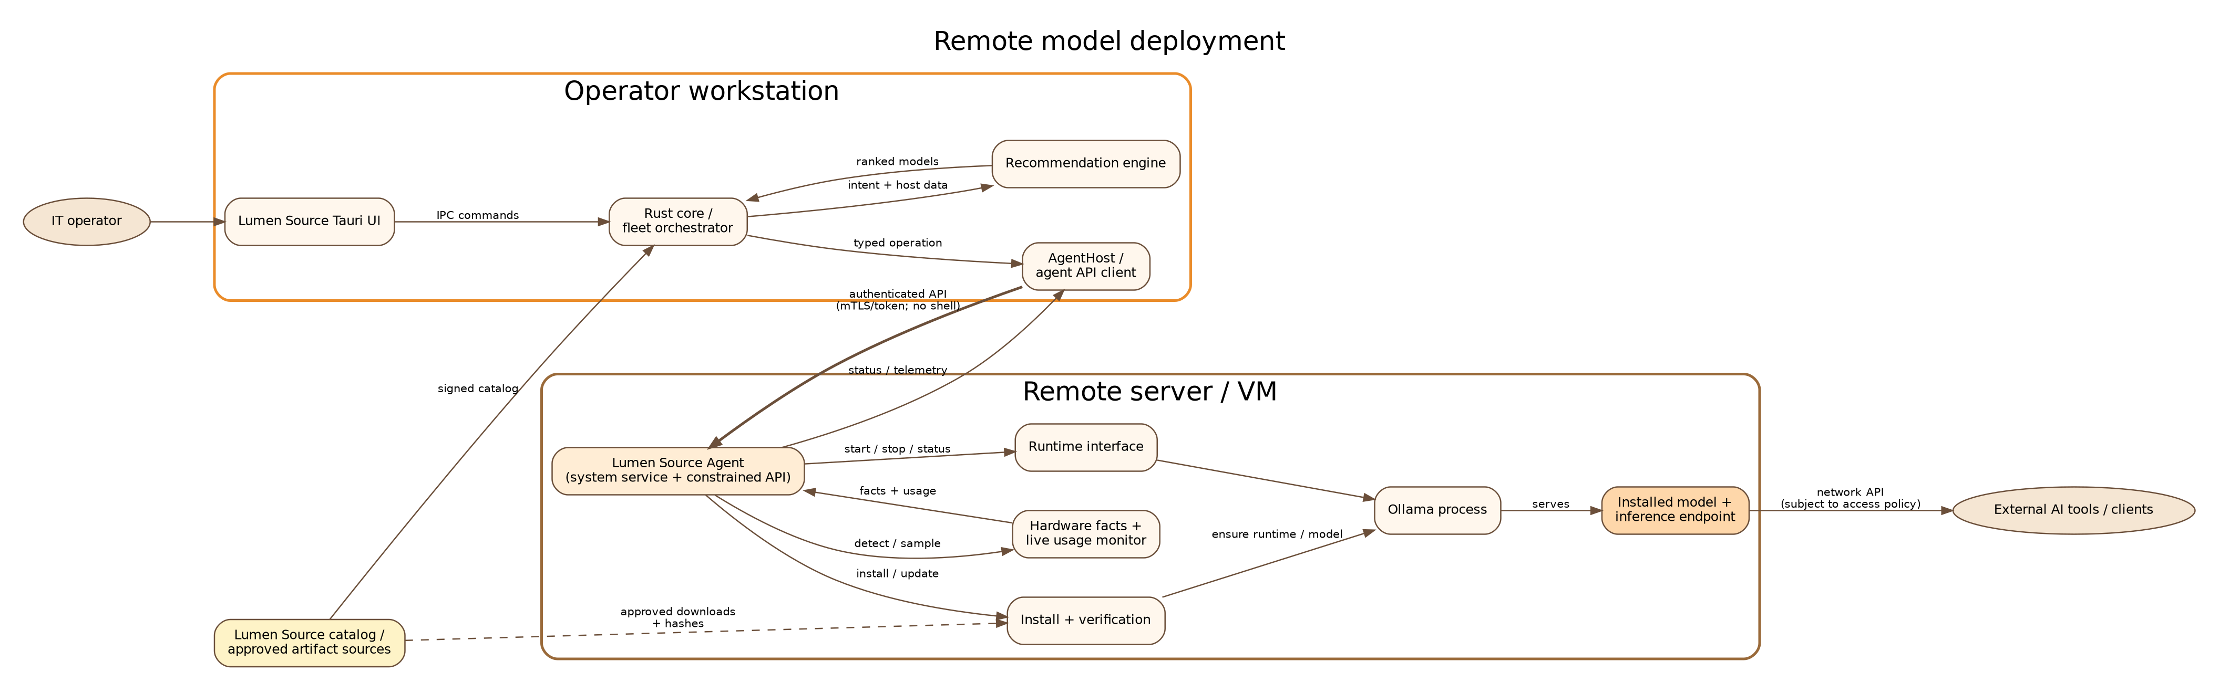
The management API is constrained: it exposes enrollment, hardware facts/usage, install/update/remove, start/stop, health, and status—not arbitrary shell execution.

3. Rust Guidelines

Error Handling
Use explicit error types.
Avoid unwrap() in production code.
Prefer Result<T, ApplicationError>.

Logging
All important operations should log:
- Startup
- Catalog fetch / validation failures
- Agent enrollment / auth failures
- Runtime changes
- Downloads
- Integrity verification results
- Hardware usage sampling anomalies (optional, rate-limited)
- Errors
- Performance measurements
Use structured logging.
Example:
{ "event":"model_download", "target":"agent-01", "model":"mistral-small", "size":"8GB", "duration":"120s", "sha256_ok": true }

Async Design
Use async Rust for:
- Catalog fetches
- Downloads
- Agent API communication
- Runtime communication
- Background tasks
Avoid blocking the main thread.

4. Testing Strategy

Unit Tests
Required for:
- Recommendation logic (including under/over-utilization right-sizing)
- Model selection / compatibility filtering
- Hardware scoring
- Catalog parsing and schema validation
- Configuration parsing
- Agent API request/response schema validation

Integration Tests
Required for:
- Runtime communication
- Model installation flows (with fixtures / fakes where possible)
- Catalog fetch + signature verification
- Operator ↔ fake-agent enrollment and management flows
- Local API / IPC endpoints

End-to-End Tests
Required for:
- First installation wizard
- Guided setup to runtime start
- Model setup happy path
- Agent enrollment happy path (can use local agent process as stand-in)
GPU- and machine-specific paths should use contract tests against fake Runtime and fake Agent implementations plus a small set of golden hardware profiles. Full multi-GPU matrix testing is not a v1 gate.

Platform CI
macOS is a first-class platform even if maintainers lack local Apple hardware. Use CI runners (and/or dedicated test devices) to build and run automated tests for macOS. Treat community beta reports as complementary validation, not as a substitute for CI.

5. Version Control
Use:
- Git
- Conventional commits
Examples:
feat: add Ollama runtime support
fix: handle missing CUDA driver
docs: update architecture

6. Dependency Management
Every dependency must have a justification.
Avoid unnecessary libraries.
Prefer:
- Mature
- Maintained
- Cross-platform

7. Code Organization
Each module should have:
- Clear responsibility
- Public interface
- Internal implementation hidden
Example modules:
- hardware/ — capacity detection, usage sampling, scoring
- catalog/ — fetch, verify, cache, query
- recommend/ — selection and right-sizing logic
- runtime/ — Runtime trait and implementations
- install/ — download, verify, install orchestration
- agent/ — agent service, API, enrollment
- hosts/ — local vs agent targets and multi-host orchestration

8. Security Guidelines
The application downloads and executes external components.
Therefore validate:
- Paths
- Downloads
- Executables
- Permissions
- Catalog authenticity
- Agent enrollment tokens and API credentials
Trust model for “easy setup”:
- Lumen Source and agents only install artifacts referenced by a verified catalog entry
- Every artifact has an expected hash; verify before install/run
- Prefer signed releases for Lumen Source, the agent, and runtimes when available
- Refuse unknown URLs, redirects outside allowlisted hosts (policy-configurable), and user-supplied shell/commands in setup flows
- Present a clear preflight summary: component, source, size, hash, license
- Do not weaken verification to “make install succeed” without explicit advanced-mode override and warnings
- Agent API is not a remote shell; scope permissions to declared operations
- Enrollment tokens are short-lived/single-use; support revoke from the operator console
“Never execute unsigned binaries” is an aspiration that may conflict with ecosystem reality. The enforceable rule is: never execute unverified artifacts. Unsigned-but-hashed vendor binaries may be allowed only when the catalog pins them and the risk is disclosed.

9. Performance Guidelines
The application must remain lightweight.
Avoid:
- Continuous heavy background processes
- Unnecessary model loading
- Excessive memory usage
- High-frequency hardware sampling that impacts inference workloads

10. Documentation Requirements
Every major component requires:
- Purpose
- API description
- Usage example
- Design decisions
Architecture changes require updating:
- Architecture document
- PRD
- Engineering guidelines

11. Agentic Development Guidelines
AI coding agents working on this project must:
Before coding:
- Understand the architecture.
- Identify affected modules.
- Avoid introducing direct dependencies on a specific runtime.
During coding:
- Follow existing patterns.
- Prefer small changes.
- Add tests.
- Update documentation.
After coding:
Verify:
- Build succeeds.
- Tests pass.
- Architecture remains valid.
- No first-party chat UI was introduced.
- UI remains free of business logic; desktop shell remains Tauri (no Electron drift without an explicit architecture change).
- Remote management does not bypass catalog trust or Runtime abstractions.
- Agent changes do not introduce arbitrary remote command execution.

12. Design Philosophy
The product should optimize for:
- Reliability
- Simplicity
- Maintainability
- Extensibility
The application should hide complexity from users while keeping the internal architecture clean.

Final Principle
The codebase should evolve like the product:
Simple for users.
Powerful for experts.
Flexible for the future.

